Assignment 12

Using the operators IN, ANY and ALL.

Q1) Write a query that selects all customers whose ratings are equal to or greater than ANY of ‘Serres’.
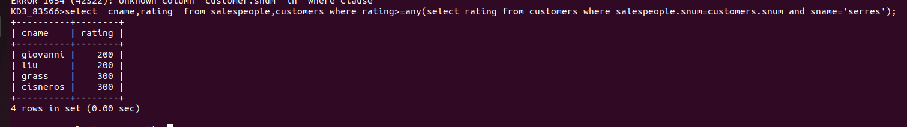

Q2) Write a query using ANY or ALL that will find all salespeople who have no customers located in their city.

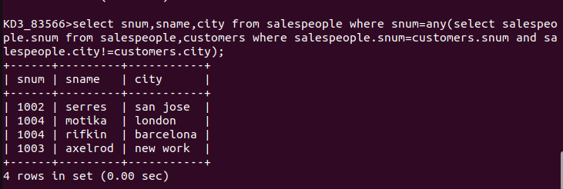

Q3) Write a query that selects all orders for amounts greater than any for the customers in London.

Method 1 – Using Subqueries

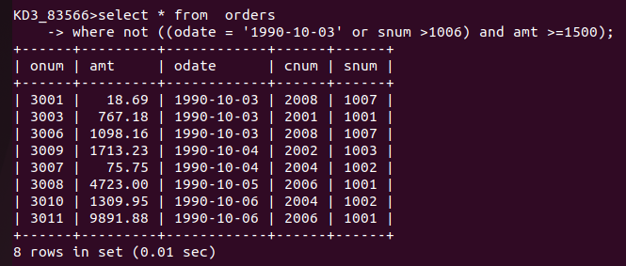

Q4) Write above query using min or max.

